**Assignment – Process Management**

1) List out highest priority process in the system

ps -eo pid,comm,ni,pri,rtprio,cls --sort=-rtprio,-pri | head

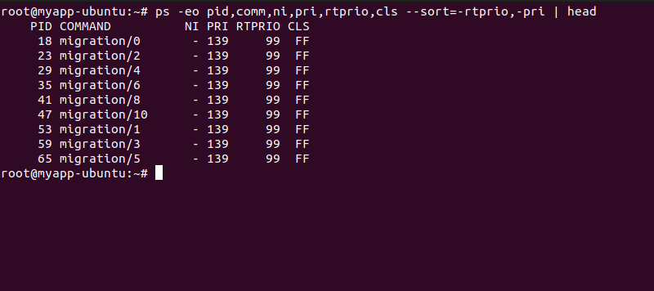

2) Open terminal with 2 tabs or sessions

a) run command "vmstat 1"

b) switch to another tab, pause running vmstat command for few seconds and

resume it again

use appropriate SIGNALS to do this activity.

vmstat 1

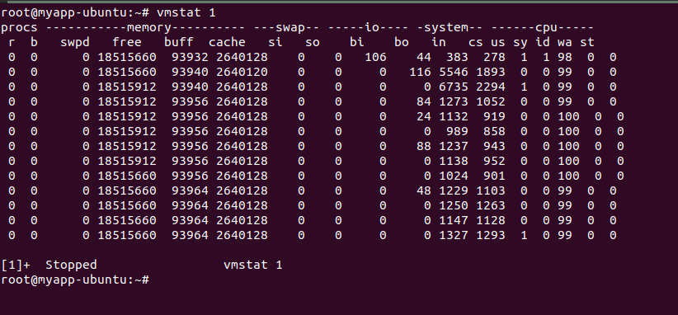

pgrep vmstat

kill -STOP 6899



kill -CONT 6899

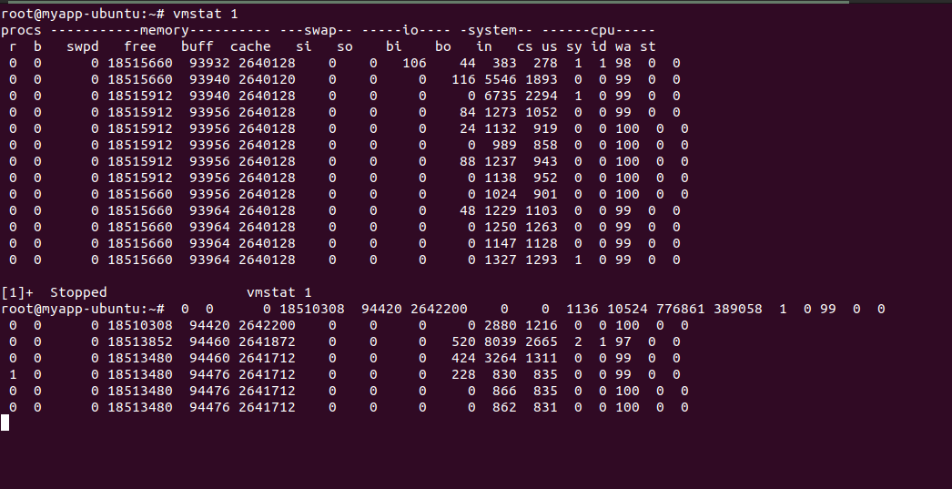

3) Find the process which is sleeping in "wait" state.

ps -o pid,ppid,state,comm -p $!

